**EXPERIMENT-6:**

6)Explore Docker commands for content management

* Install docker in aws instance
* Login to aws
* Connect to the instance
* Follow the commands
* **sudo apt install apt-transport-https ca-certificates curl software-properties-common -y**
* **sudo curl -fsSL https://download.docker.com/linux/ubuntu/gpg -o /etc/apt/keyrings/docker.asc**
* **echo "deb [arch=$(dpkg --print-architecture) signed-by=/etc/apt/keyrings/docker.asc] https://download.docker.com/linux/ubuntu $(. /etc/os-release && echo "$VERSION_CODENAME") stable" | sudo tee /etc/apt/sources.list.d/docker.list > /dev/null**
* **sudo apt update**
* **sudo apt-get install docker-ce docker-ce-cli containerd.io docker-buildx-plugin docker-compose-plugin**
* **sudo docker –version**
* **sudo systemctl enable docker**
* 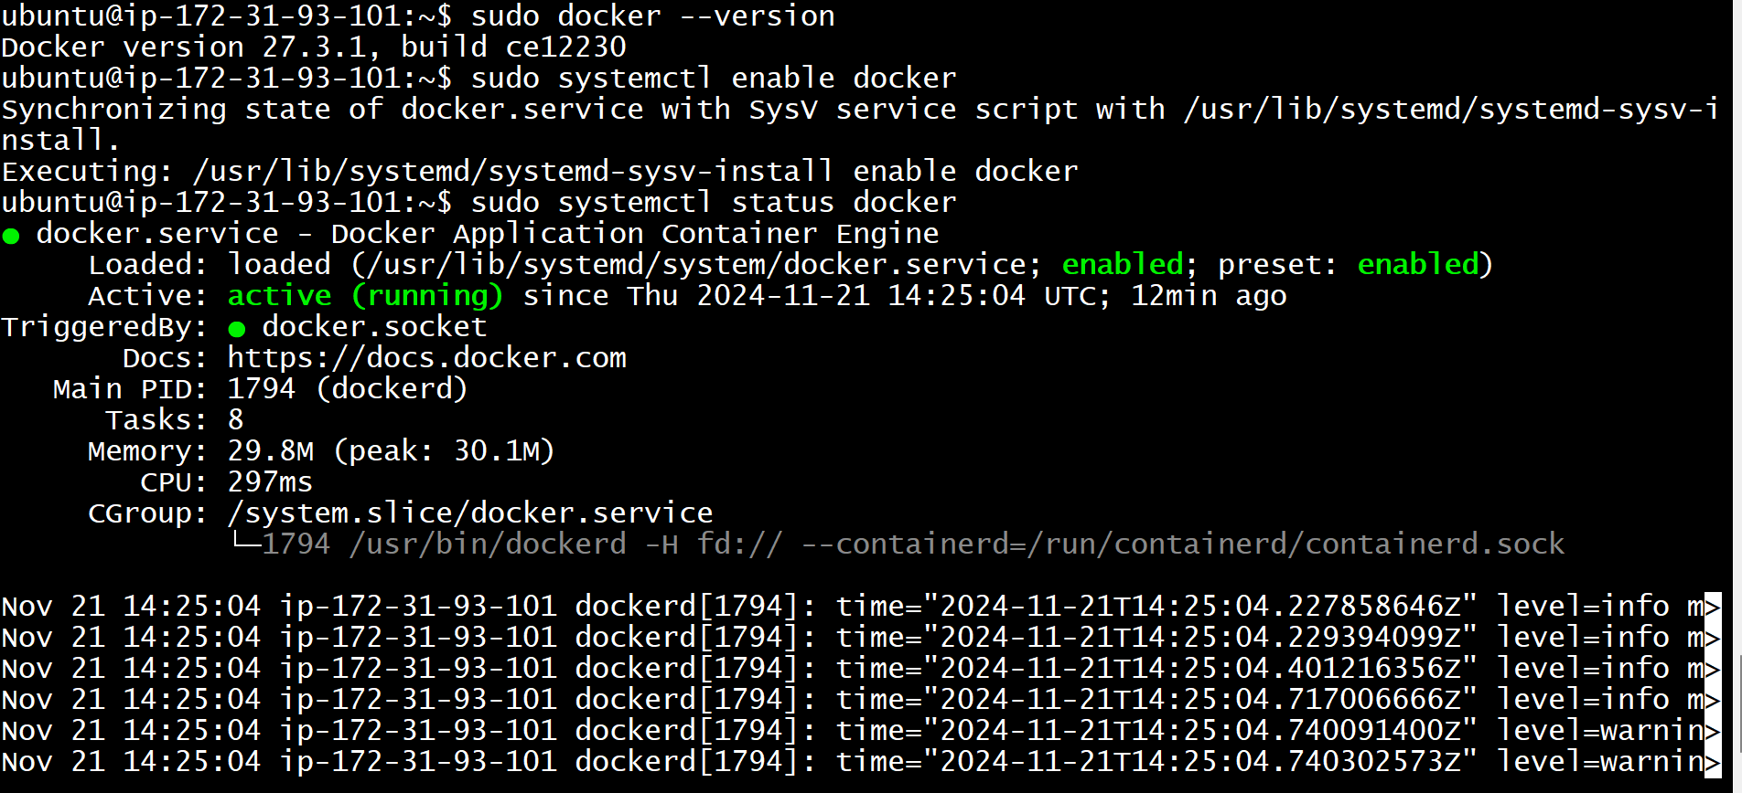**sudo systemctl status docker**
* **Simple Docker commands:**

**ubuntu@ip-172-31-93-101:~$ sudo su**

**root@ip-172-31-93-101:/home/ubuntu# docker images**

REPOSITORY TAG IMAGE ID CREATED SIZE

**root@ip-172-31-93-101:/home/ubuntu# docker run hello-world**

Unable to find image 'hello-world:latest' locally

latest: Pulling from library/hello-world

c1ec31eb5944: Pull complete

Digest: sha256:305243c734571da2d100c8c8b3c3167a098cab6049c9a5b066b6021a60fcb966

Status: Downloaded newer image for hello-world:latest

Hello from Docker!

This message shows that your installation appears to be working correctly.

To generate this message, Docker took the following steps:

1. The Docker client contacted the Docker daemon.

2. The Docker daemon pulled the "hello-world" image from the Docker Hub.

(amd64)

3. The Docker daemon created a new container from that image which runs the

executable that produces the output you are currently reading.

4. The Docker daemon streamed that output to the Docker client, which sent it

to your terminal.

To try something more ambitious, you can run an Ubuntu container with:

$ docker run -it ubuntu bash

Share images, automate workflows, and more with a free Docker ID:

https://hub.docker.com/

For more examples and ideas, visit:

https://docs.docker.com/get-started/

**DOCKER IMAGES**

**root@ip-172-31-93-101:/home/ubuntu# docker images**

REPOSITORY TAG IMAGE ID CREATED SIZE

hello-world latest d2c94e258dcb 18 months ago 13.3kB

**DOCKER CONTAINER**

**root@ip-172-31-93-101:/home/ubuntu# docker ps**

CONTAINER ID IMAGE COMMAND CREATED STATUS PORTS NAMES

**root@ip-172-31-93-101:/home/ubuntu# docker ps -a**

CONTAINER ID IMAGE COMMAND CREATED STATUS PORTS NAMES

8f70f6c63656 hello-world "/hello" 57 seconds ago Exited (0) 55 seconds ago serene_kilby

**root@ip-172-31-93-101:/home/ubuntu# docker ps -a -q**

8f70f6c63656

**DOCKER PULL**

**NGINX**

**root@ip-172-31-93-101:/home/ubuntu# docker pull nginx:latest**

latest: Pulling from library/nginx

2d429b9e73a6: Pull complete

9b1039c85176: Pull complete

9ad567d3b8a2: Pull complete

773c63cd62e4: Pull complete

1d2712910bdf: Pull complete

4b0adc47c460: Pull complete

171eebbdf235: Pull complete

Digest: sha256:bc5eac5eafc581aeda3008b4b1f07ebba230de2f27d47767129a6a905c84f470

Status: Downloaded newer image for nginx:latest

docker.io/library/nginx:latest

**root@ip-172-31-93-101:/home/ubuntu# docker images**

REPOSITORY TAG IMAGE ID CREATED SIZE

nginx latest 60c8a892f36f 7 weeks ago 192MB

hello-world latest d2c94e258dcb 18 months ago 13.3kB

**root@ip-172-31-93-101:/home/ubuntu# docker ps**

CONTAINER ID IMAGE COMMAND CREATED STATUS PORTS NAMES

**root@ip-172-31-93-101:/home/ubuntu# docker ps -a**

CONTAINER ID IMAGE COMMAND CREATED STATUS PORTS NAMES

8f70f6c63656 hello-world "/hello" About a minute ago Exited (0) About a minute ago serene_kilby

**DOCKER RUN**

**root@ip-172-31-93-101:/home/ubuntu# docker run -d -p 2024:80 nginx:latest**

a0b67c0afb4131db0ccd3b9e6dd1e7510d7793af032bdea3f05bc37324068127

* Add inbound rules with port 2024 in aws instance and in new tab public ip:2024



**JENKINS**

**root@ip-172-31-93-101:/home/ubuntu# docker pull jenkins:1.651.3**

1.651.3: Pulling from library/jenkins

5c90d4a2d1a8: Pull complete

ab30c63719b1: Pull complete

c6072700a242: Pull complete

5f444d070427: Pull complete

620b5227cf38: Pull complete

3cfd33220efa: Pull complete

864a98a84dd2: Pull complete

734cc28150de: Pull complete

83a54d30c146: Pull complete

ed85ef8f0008: Pull complete

2a8cac69db6b: Pull complete

1ebd85d16913: Pull complete

1f6dfc1a1369: Pull complete

c3f94a642af3: Pull complete

09d08f86656b: Pull complete

4a944589c63c: Pull complete

994cb79653b9: Pull complete

ea153d9ec0fc: Pull complete

Digest: sha256:87f2fbfe61b74f77460c8896074e5d3c808791d2da6401c5e5b9ce1805649d7e

Status: Downloaded newer image for jenkins:1.651.3

docker.io/library/jenkins:1.651.3

**root@ip-172-31-93-101:/home/ubuntu# docker run -d -p 2027:8080 jenkins:1.651.3**

3a48a5324c722c356e6354c6651e483a36f70cacbb77d3e782f266b97e4741f4

**root@ip-172-31-93-101:/home/ubuntu# docker ps**

CONTAINER ID IMAGE COMMAND CREATED STATUS PORTS NAMES

3a48a5324c72 jenkins:1.651.3 "/bin/tini -- /usr/l…" 10 seconds ago Up 8 seconds 50000/tcp, 0.0.0.0:2027->8080/tcp, [::]:2027->8080/tcp quirky_spence

a0b67c0afb41 nginx:latest "/docker-entrypoint.…" 4 minutes ago Up 4 minutes 0.0.0.0:2024->80/tcp, [::]:2024->80/tcp flamboyant_hopper

* 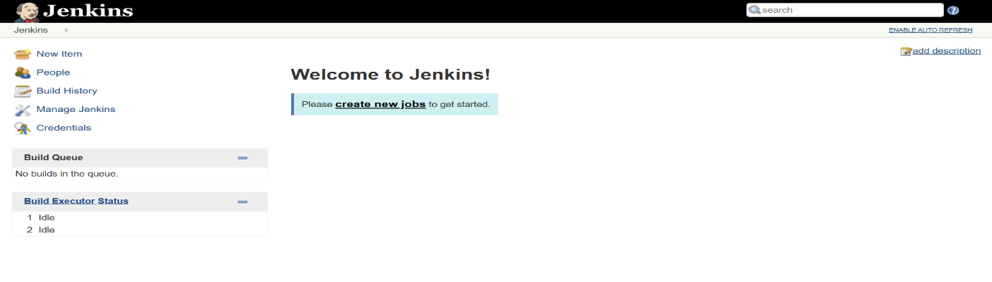Add inbound rules with port 2027 in aws instance and open new tab public ip:2027